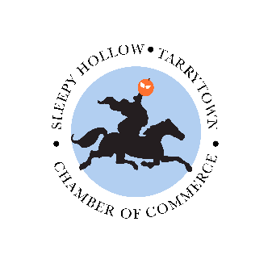

To Sleepy Hollow ~Tarrytown Chamber of Commerce Family and Friends,
As the State of New York is on a mandatory “Pause”, we want you to know that you are all extremely important to the leadership of the SH/TT Chamber of Commerce. We will continue to provide you with daily updates, resource guidance, and timely information to assist you in continuing in your professional lives as much as possible. It goes without saying that we fully support the efforts of both Governor Cuomo and Mayors Fixell and Wray during this extremely challenging time.
COVID-19 has hijacked many businesses, severely affecting owners and workers. Non-profit organizations are struggling to survive, many on the front-lines trying to assist those who need the most help now, including our economically-challenged and homeless populations. All of us are greatly impacted during this unprecedented crisis.
Let’s practice compassion, empathy and take care of our families and each other during this challenging time. The anxiety is real and we need to support each other. We will come out of this together stronger than ever with a bright future in the days ahead.
If we can help you in any way, please don’t hesitate to reach out us at -
With resilience and strength together,
The Executive Board of The SH TT Chamber of Commerce

Some helpful real-time information:

LAST UPDATED: MARCH 21, 2020 9:15AM
What You Need to Know
- New York State on PAUSE: In New York we know that Policies Assure Uniform Safety for Everyone
- Governor Cuomo will sign an Executive Order mandating that 100% of the workforce must stay home beginning Sunday, March 22 at 8PM, excluding essential services.
Check here for definitions of essential services:
https://esd.ny.gov/guidance-executive-order-2026?fbclid=IwAR1XnnhTlPoglw8RUH8AspQbfPIgpwG63OcUyea32d9TM8oQCikWE8wYfqM

- All non-essential gatherings of individuals of any size for any reason are temporarily banned.
- Enacting Matilda’s Law to protect New Yorkers age 70+ and those with compromised immune systems
  - Remain indoors
  - Can go outside for solitary exercise
  - Pre-screen all visitors by taking their temperature
  - Wear a mask in the company of others
  - Practice physical distancing - stay at least six (6) feet from others
  - Do not take public transportation unless urgent and absolutely necessary
- All barbershops, hair salons, tattoo or piercing salons, nail salons, hair removal services and related personal care services will be closed to the public effective Saturday, March 21 at 8:00PM.
- New York will implement a 90-day moratorium on evictions for residential and commercial tenants.
- Casinos, gyms, theaters, retail shopping malls, amusement parks and bowling alleys are closed until further notice. Bars and restaurants are closed, but takeout can be ordered during the period of closure.
- Testing is free for all eligible New Yorkers as ordered by a health care provider.
- Your local health department is your community contact for COVID-19 concerns.

Sign up for email updates from New York State with critical information on the Coronavirus pandemic.

LINKS TO CHECK OUT NOW

https://esd.ny.gov/esd-covid-19-related-resources

https://www.sba.gov/disaster-assistance/coronavirus-covid-19

https://westchestercatalyst.com/coronavirus-updates/

